# SNU developer log Week 62

## SNU developer log day 428

I wrote a "hidden" comment yesterday about my issues lately and how they benefited the April Fools joke. They actually did. I have been having ongoing severe issues with tension for 3 days now, the first 2 days were intolerable for work. I have had issues with jaw tension my whole life, and I have taken medications for it. There is currently an issue with hypertension that I am working out, but it was good enough today to let me actually work on my website. I had more time to work on it as well, and the sun is finally shining outside again today (it has been hailing and raining a lot lately)

I was going to work on the Internet Museum more today, but I had some other projects I wanted to work on. I thought I started a 3D printing part of the site, but it turns out, I didn't. So today, I added in a 3D printing center to the site, and a place to make puzzles, as VLC has the option, but SNU needs its own puzzle system. I also did the usual documentation, with preparation for the week 61 article to be exported, and also I worked on a few pages on the SNU Internet Museum. Today was a comeback day from 2 days of failure after hypertension in my jaw stopped me dead in my tracks. I hope to continue development strong again tomorrow.

So a change will happen to the developer log soon (before April 25th 2020) I originally tried to have a daily separate blog system back in the beginning of SNU 3 development, but it died off, as it was too hard to manage. I have now been managing a new attempt of this for both the developer log and update log for over a month now, and I have done a great job on it. I will replace the original dead links with a JsvaScript alert, then when I get more advanced, it will just redirect to the dead link if chosen. This is a small change, but it will be the first usage of the JavaScript [alert] element on the developer log.

I did pretty well with site development today. I am starting to get back to site development again. Spring Break is coming up soon, so I will have even more site development time if I can schedule right and keep up.

I was reintroduced to VLC later tonight. After a bunch of fatal crashes last year, I decided to give it a try again this year after accidentally opening a file. It is something I have been missing for a long time. It is the likely missing piece to the lack of happiness I have had for months now. Even with crashes, I am going to keep using it.

Sean Patrick Myrick on April 2nd 2020

## SNU developer log day 429

I was a lot more unscheduled today, despite having a lot more time. I was able to make a smaller update, I didn't plan for much more today. Earlier this afternoon, my laptop began to have its CPU memory leak issue again, and I was able to counter it for now. If it gets worse again tomorrow (If a process with SYSTEM permissions has a memory leak) development might go much worse. I was able to save it today though.

I would have done more today if I would have planned for more. Today, I worked mainly on documentation, with a daily update to the SNU Internet Museum (1 more page was modernized today, and the twitter page received some updates) other than that, it was a small development day. I have many new ideas that I came up with that I will try to start working on tomorrow, I just didn't have as much time today.

I feel as though I haven't been making enough progress lately. I have been working on improving this, but I am balancing a lot of issues. I have been starting work an hour earlier lately (session 1 normally goes from 2:00 pm to 5:30 pm with all my laptop projects, then between 7:50 pm and 10:20 pm for my second session of laptop projects) I have a lot of projects I work on, and SNU is getting to the point where I need community collaboration, I am just not entirely ready yet, especially due to the quarantine/

Sean Patrick Myrick on April 3rd 2020

## SNU developer log day 430

I did a 3 stage test on my laptops CPU earlier today, it does not have any issues today. I have finally settled down with VLC, and I am getting a better schedule now, so I was able to do some improved site development today. I worked further on the internet museum, but brought a spoofed error message/update center to the site as a joke. I know another site that does the same thing, but it is malicious and insecure. I hope to make an improved version.

I would do more, but I didn't have as much time again today. I have a really bad schedule and I have been working hard on balancing it. Today I did work on documentation as well as work on the internet museum. I discovered a lot more pages that need to be recreated, and it is going to take a while to get these pages up to a high standard with the less than 4 hours a day I have to work on SNU. I have many other projects, some of them have been held off so I can try and make a better site update. I still have to fix my schedule. If I can optimize it to get to work before 12:00 pm again, I should do really well. Right now, website work seems to start at 3:30 pm and later. It is a horribly optimized schedule.

The SNU Developer surpassed 1 million characters yesterday, but I forgot to mention it. Today was a decent day for development, I hope to improve and balance everything soon. I had to cut all work to the Internet Museum from development tonight, as I ran out of time.

Sean Patrick Myrick on April 4th 2020

## SNU developer log day 431

I had a lot more time today, as I started much earlier. I had a lot to do today, and I got more done. Today, along with documentation, I updated the SNU PFOSS Exchange repository, updated the blue screen spoof page from yesterday, created a privacy article, updated the Internet Museum, and created a SourceBase template remix so that I can update SNU more efficiently, without spending extra time modifying the template. I started far before 4:00 pm today, and it caused me to get a lot more done.

For the Blue Screen of Death prank page, I am going to try and get feedback from my brother in law, as he works at Microsoft. I have been having some issues perfecting the page. I think the Windows 8 and 10 errors will be harder to reproduce. I also made some more brandless pages of the site as part of an update to the PFOSS exchange center. I limited how many things I did today so I don't overwhelm myself. Things went very well today. I hope I can continue this trend, and also balance online school better. Today was a good day for development.

Sean Patrick Myrick on April 5th 2020

## SNU developer log day 432

I seem to be getting better and better again lately. I had no tension issues today, and I was really focused while working. I managed to get a lot done again today. I worked on a new video player page, the last test was unsuccessful, but I am going to try harder this time. I also updated the article on Zoom and privacy, and created an article about the Pandemic and privacy. I also began to make a system for SNU that involves encrypting user data, I have found a new effective way of increasing security, which is to automatically reload keys after a set amount of time. This might use up too much CPU and bandwidth for some people, so it isn't forced on the user, it is a choice with settings. I also worked on the Internet Museum again today.

I was inspired to try and do a lot today, and I made some progressive with the 3+ hours I had to work today. I really wonder right now if I am even going to be able to get back into the school schedule again after the quarantine ends. I am feeling even more ready lately to start and expand the development of this project, but I am stuck with waiting until quarantine ends first. The site really has come a long way. It is amazing that it has gotten to this point from the point where it was me just linking files to each other, and using heading tags. This site has greatly expanded my knowledge on web development. Today waa another good day for development.

Sean Patrick Myrick on April 6th 2020

## SNU developer log day 433

I had another really good day with development again today. It was also announced last night that school is canceled for the summer and that all classes will be online now. So I don't have to worry about going back to school and getting back into schedule anymore. Today I worked on documentation, an update to the SNU Video center, which is going to be a massive part of the site. I also did an update to the Internet Museum, I have a working format for page syntax going now, and I wanted to update it today. I also worked on a new Health Center, which will be a part of the site dedicated to health, and I also did some critical updates to SourceBase. I would do more, but I don't have as much time today, and I don't want to overwhelm myself.

The new SNU Standard template is working really well for me, it has significantly sped up page development time for new pages. On the Blue screen project, I still have gotten no feedback back from my brother-in-law, I might need to remind him about it. Today was another really good day for development, development has been going semi-strong for 3 days now. I am also doing well in some of my other projects, but I might need some time to work on 2 projects. I haven't set up a time for it yet.

So an update on Cobie, we had him up until today, but we weren't able to foster him. He was a really good dog, but we weren't the right family for him. After he started peeing all over the house, and after running off 7 times (We had to catch him 7 times, he managed to fit through the doggy door, and we had to chase after him across the neighborhood, even at midnight) we had to take him back today. As a parting present, we gave him one of our dog beds that he liked, I will miss him, but I hope he finds a family that can care for him well. He is an outside dog, but we are well-used to inside dogs.

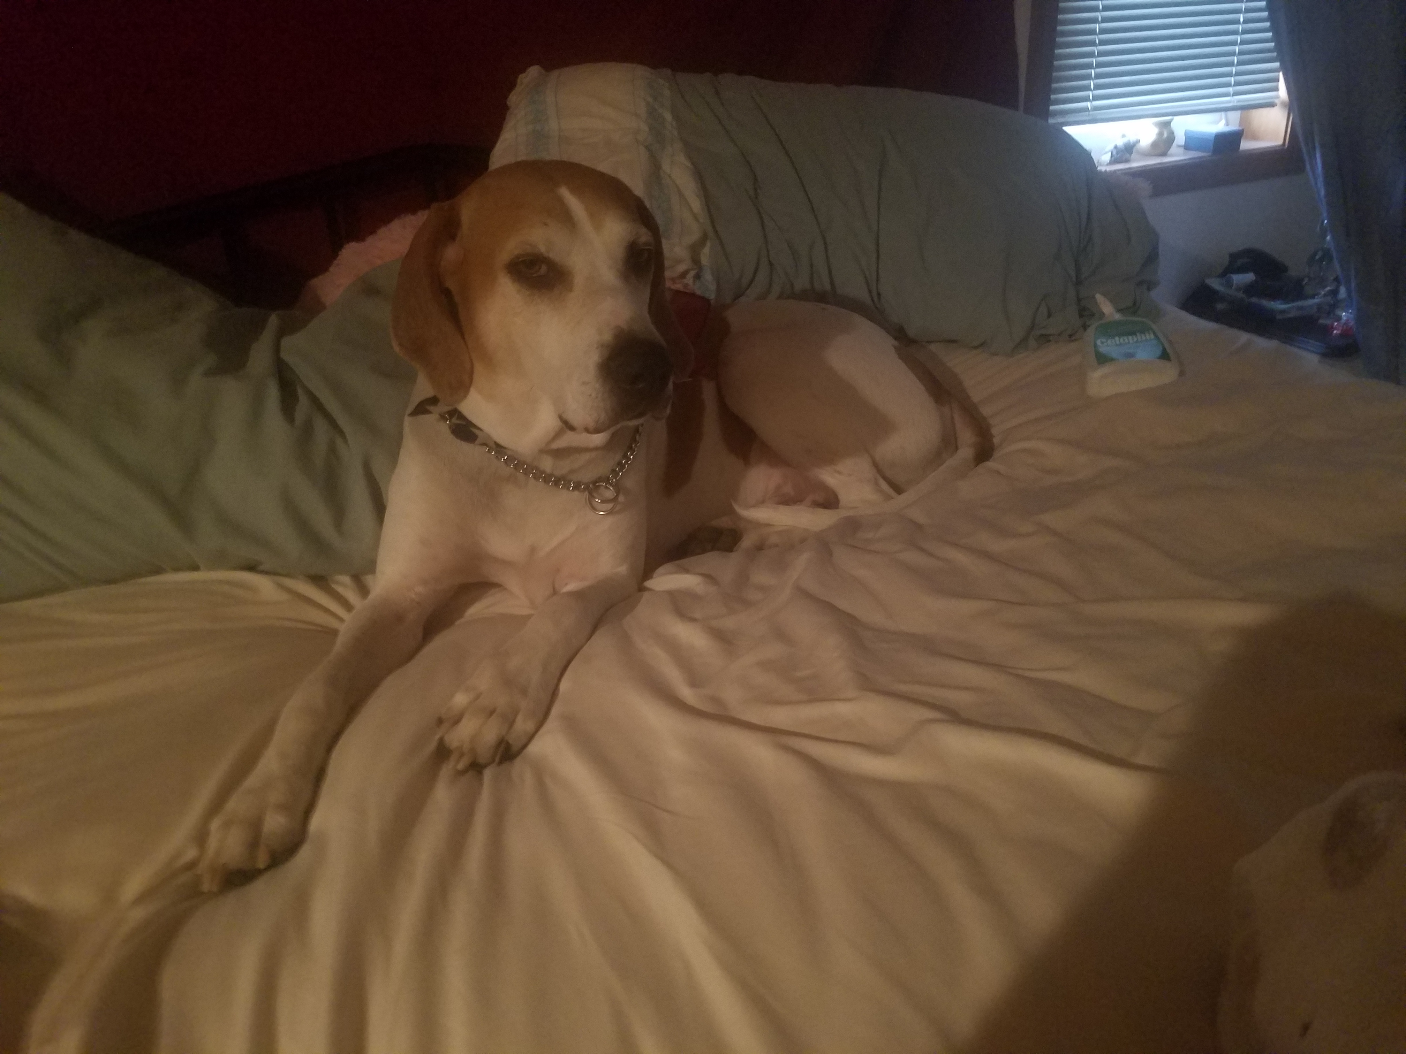He at least had a good time with us. It was definitely better than staying at the Humane Society through all of Quarantine. Here is the best picture I have of him.

Sean Patrick Myrick on April 7th 2020

## SNU developer log day 434

I had less development time today, as I woke up later. I didn't plan as much today due to this, as I want to keep it to a reasonable amount. Today, I worked on documentation, a new Torrent section of the site (SNU Torrent, codename omicronTorrent, or simply oTorrent) and a big update (commit-wise) to the SNU Internet Museum, trying to finalize the Valve page. For external documentation, I have decided that I will have support for 6 new formats: Mobi, xml, xps, fodt, doc, and docm. However, it would be too difficult to make 12 additional commits each day, I want to save time for other work. Plus, I don't have any software right now that can create Mobi or XPS files. Today, when exporting the developer log entry, it was the biggest entry I have ever exported, purely because of the 4K image that I included. I was expecting document size to be hundreds of times bigger than usual, but something happened to the RTF export which I found unacceptable: the file took up over 151 megabytes. So to save space, I unfortunately had to modify this document to remove the image. I might create an exception in the future, but right now, I am trying to balance the size of SNU better.

My brother-in-law said he would check out the fake BSoD page that I created, he has been very busy at Microsoft lately, preparing their services to handle more people better. He got to me about it last night before bed. This might pave the way for more spoof pages to be created and updated. Today was a decent day for development, I tried to take it easier today.

Sean Patrick Myrick on April 8th 2020